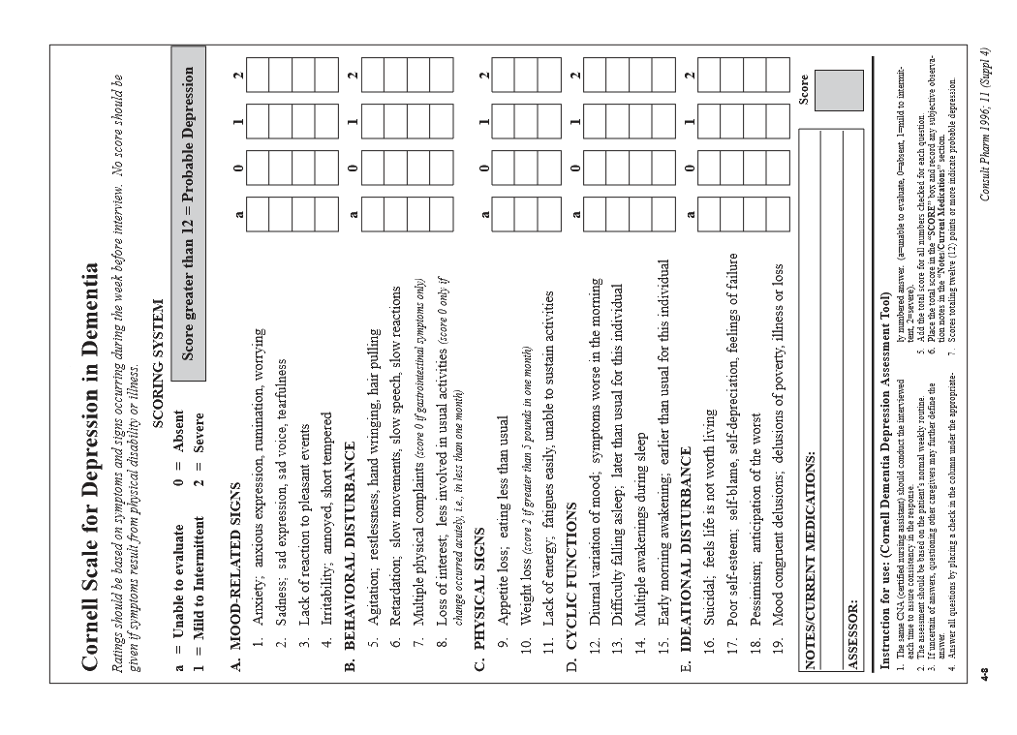\*For more information see NGH Care Plan Guidelines.

Nightingale Hammerson May 2016 C16b – Page 1 of 1